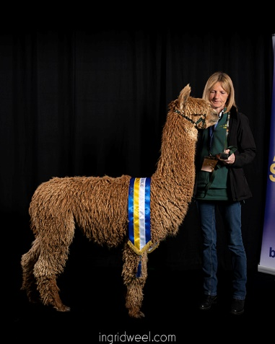**Curriculum Vitae**

**Julia Corrigan-Stuart**

**Contact Details:** CS Alpacas

Yeat Wood Farm, Wotton Underwood, Bucks HP18 0RL

Telephone: 07803726464 Email: [julia@csalpacas.co.uk](mailto:julia@csalpacas.co.uk)

**Certified: 23rd September 2019.**

My father was in the Armed Forces, so I spent my younger years in Germany. I started work at the National Farmers Union in Knightsbridge, London and then moved into the City to work for an Insurance company, where I met my husband, James. After having my 2 children, John and Jack, I retrained as a teacher and taught in primary schools until 2007, when I turned my hand to designing and converting derelict barns as our home. This was when I became involved in alpacas – the barns had 12 acres of land that needed to be grazed! I started with 3 pregnant female huacayas – I now have circa 140 alpacas, half huacaya and half suri, grazing on 100 acres of land. My son, Jack, works alongside me on the farm.

With my thirst for knowledge of alpacas, I attended all the BAS Courses available, offered my services as a handler on judge courses and then chose the Judging route. At the same time I became heavily involved with the BAS National Fleece Show, now known as the Champion of Champions Fleece Show, organising it from 2013 to date. I am also very involved in the Heart of England Alpaca Regional Group, having been the Fleece Show Organiser for the past 12 years and the Chief Steward for the Fiesta for the past 8 years. I also host numerous of the BAS courses on farm, from the Advanced Alpaca course, through to the Judge 1 and Judge 2 courses. I am also a qualified Affiliate Trainer. I have also travelled to Peru for their Alpaca Fiesta and visited the main processing Mills, as well as attending the Annual Suri Symposium in the USA. I have travelled all round the UK and Europe, judging both halter and fleece, as well as attending calibration clinics and workshops with both British and International Judges.

Having certified in 2019, then everything being quiet on the judging front due to the Covid Pandemic, I now thoroughly enjoy and feel very privileged to be judging both Huacayas and Suris in the Ring and also judging Fleeces on the table, seeing the excellent quality that we are now producing in the UK and Europe. My main aim is to be able to offer guidance and education to Exhibitors and the Public at all Shows. I would like my reputation as a judge to be known for being fair, impartial and objective, judging to the set BAS Judging criteria.

**Judging History:**

2020 - No judging due to the Pandemic

2021 - Westmorland Halter Show

1. - Finnish Halter Show

* Austrian Fleece Show
* Welsh Alpaca Halter Show
* Northern Fleece Show

2023 - North West Alpaca Group Halter Show

- North Somerset Halter Show

- CCA Halter Show

- HoEAG Fleece Show

- NI Halter Show

2024 - HoEAG Halter Show

- CCA Fleece Show

**Upcoming Judging Commitments:**