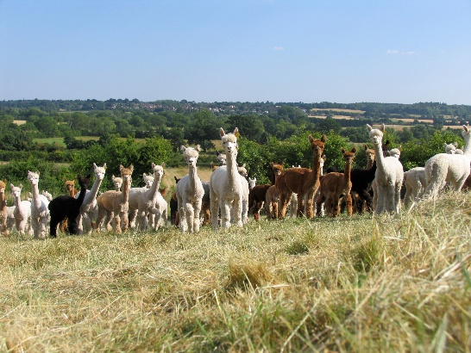
Update on Defra bTB Figures for Camelids in the UK

26th November 2025

Absence of New bTB Cases in 2024
There were no new laboratory-confirmed Bovine Tuberculosis (bTB) incidents reported in camelids (alpaca and llama) throughout the entirety of 2024. This positive outcome is further supported by a nil return for infected camelids discovered during post-mortem examinations. Notably, this continues a downward trend in camelid bTB cases observed since 2019.

Progress Reflected in Data
This continued reduction in bTB amongst alpacas is a testament to the diligent biosecurity measures adopted by herd owners such as badger proof fencing, disinfection, surveillance Enferplex testing including whole herd, pre and post movement and post movement isolation. Their consistent efforts have played a crucial role in maintaining healthy herds and reducing the prevalence of the disease.

Statistical Overview of Camelid bTB Cases
 | 2015 | 2016 | 2017 | 2018 | 2019 | 2020 | 2021 | 2022 | 2023 | 2024
Lab confirmed bTB breakdowns | 13 | 8 | 11 | 9 | 10 | 4 | 2 | 1 | 3 | 0
Registered BAS herd | 1,203 | 1,243 | 1,320 | 1,333 | 1,424 | 1,540 | 1,580 | 1,746 | 1,706 | 1,619
Registered population | 36,960 | 38,490 | 39,048 | 40,521 | 41,526 | 43,232 | 38,449 | 39,390 | 41,084 | 44,886
Estimated UK alpaca population | 52,000 | 54,000 | 56,000 | 58,000 | 60,000 | 60,000 | 60,000 | 62,000 | 62,000 | 62,000
Estimated herds in the UK | 2,300 | 2,350 | 2,400 | 2,450 | 2,500 | 2,500 | 2,500 | 2,600 | 2,600 | 2,600
% herds affected by bTB per year | 0.6 | 0.3 | 0.5 | 0.4 | 0.4 | 0.2 | 0.1 | 0.05 | 0.15 | 0.00

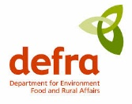
The complete data set is available for reference on the GOV.UK website under 'Data on bTB in Non-Bovine Species'.
Data on TB in Non-Bovine Species - GOV.UK

Shows

To this date, there has been no evidence of bTB being spread at British Alpaca Society (BAS) halter shows with no historic cases ever traced to a show source. With the implementation of the biosecurity rules, this is again a testament to the diligence of the industry where over 30,000 alpacas are estimated to have come through the show circuit since 1999.

Export
In 2021 the UK government (DEFRA) created an additional level of biosecurity for alpacas leaving the UK for the EU. This involved not only following all EU testing requirements but also adding another layer of protection where ALL alpacas on the UK exporting farm must have a Single Intradermal Comparative Cervical Tuberculin (SICCT) test, commonly known as a bTB skin test, followed by an Enferplex antibody Blood-test. Only farms that have this double bTB testing regime implemented on all of their alpacas, with negative results, are allowed to export to the EU. The test results are verified by a government authorised veterinarian before the Export Health Certificate (EHC) is signed and stamped. This means that the alpacas leaving the UK have the most stringent testing regime in Europe and if an exporting farm has bTB, this thorough testing regime will statistically find it and the farm will be placed under immediate movement restrictions preventing the disease being spread.

Working with our EU neighbours
The British Alpaca Society is committed to the long term future of the alpaca industry and welcomes EU based alpaca associations to work together to ensure the steady flow of much needed new genetics between countries. The UK needs to import new genetics too and only by working together to share these genetics can we improve the productivity of the alpaca and drive towards a brighter and more sustainable future.

This update is brought to you by:

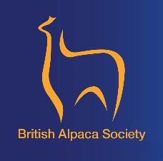 |  | 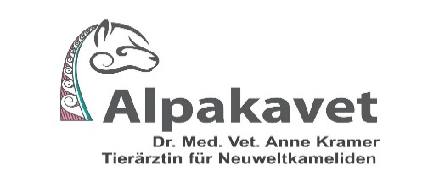
Sue Loach  BAS Chairman | Claire Whitehead  BVM&S MS DACVIM(LA) FHEA MRCVS | Anne Kramer  DVM MANZCVS CertAVP (Camelid)

